MACH4METAL

Metalworking machinery
Transito 21,
6909 DA BABBERICH
Netherlands
Tel. +31 (0)316 – 247123
Fax. +31 (0)316 - 247956
info@mach4metal.com
www.mach4metal.com

Account No: 66.52.13.883
IBAN : NL33 INGB 0665 2138 83
BIC : INGBNL2A

CNC UNION HECKERT BFT 110/6

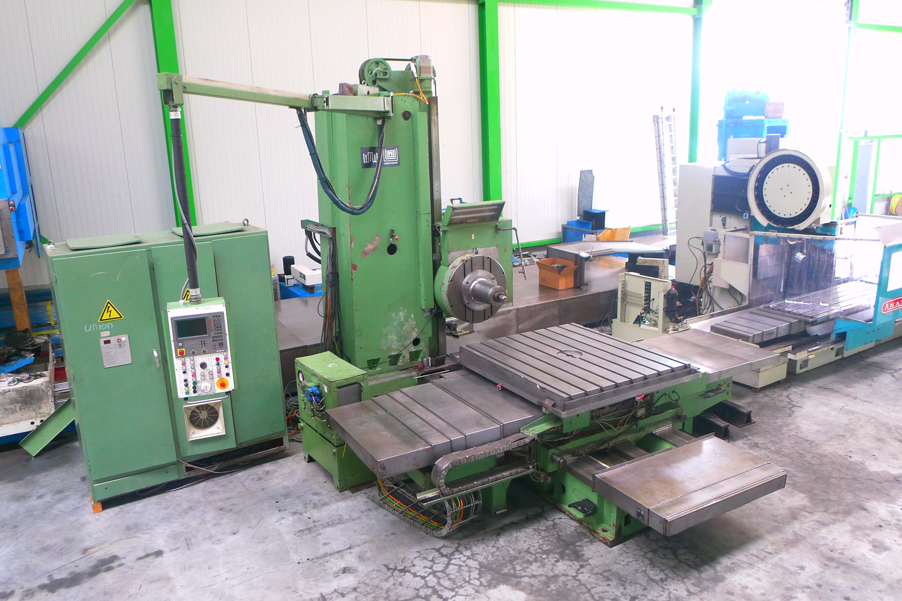
- Make : Union Heckert Germany
- Typ : BFT 110
- Mach.No : 11242
- Age : Retro 04.2008

- X – travel : 1.940
- Y – travel : 1.600
- Z – travel : 1.940
- W – travel : 800
- U – travel : 250

- Rotary table length : 1.600
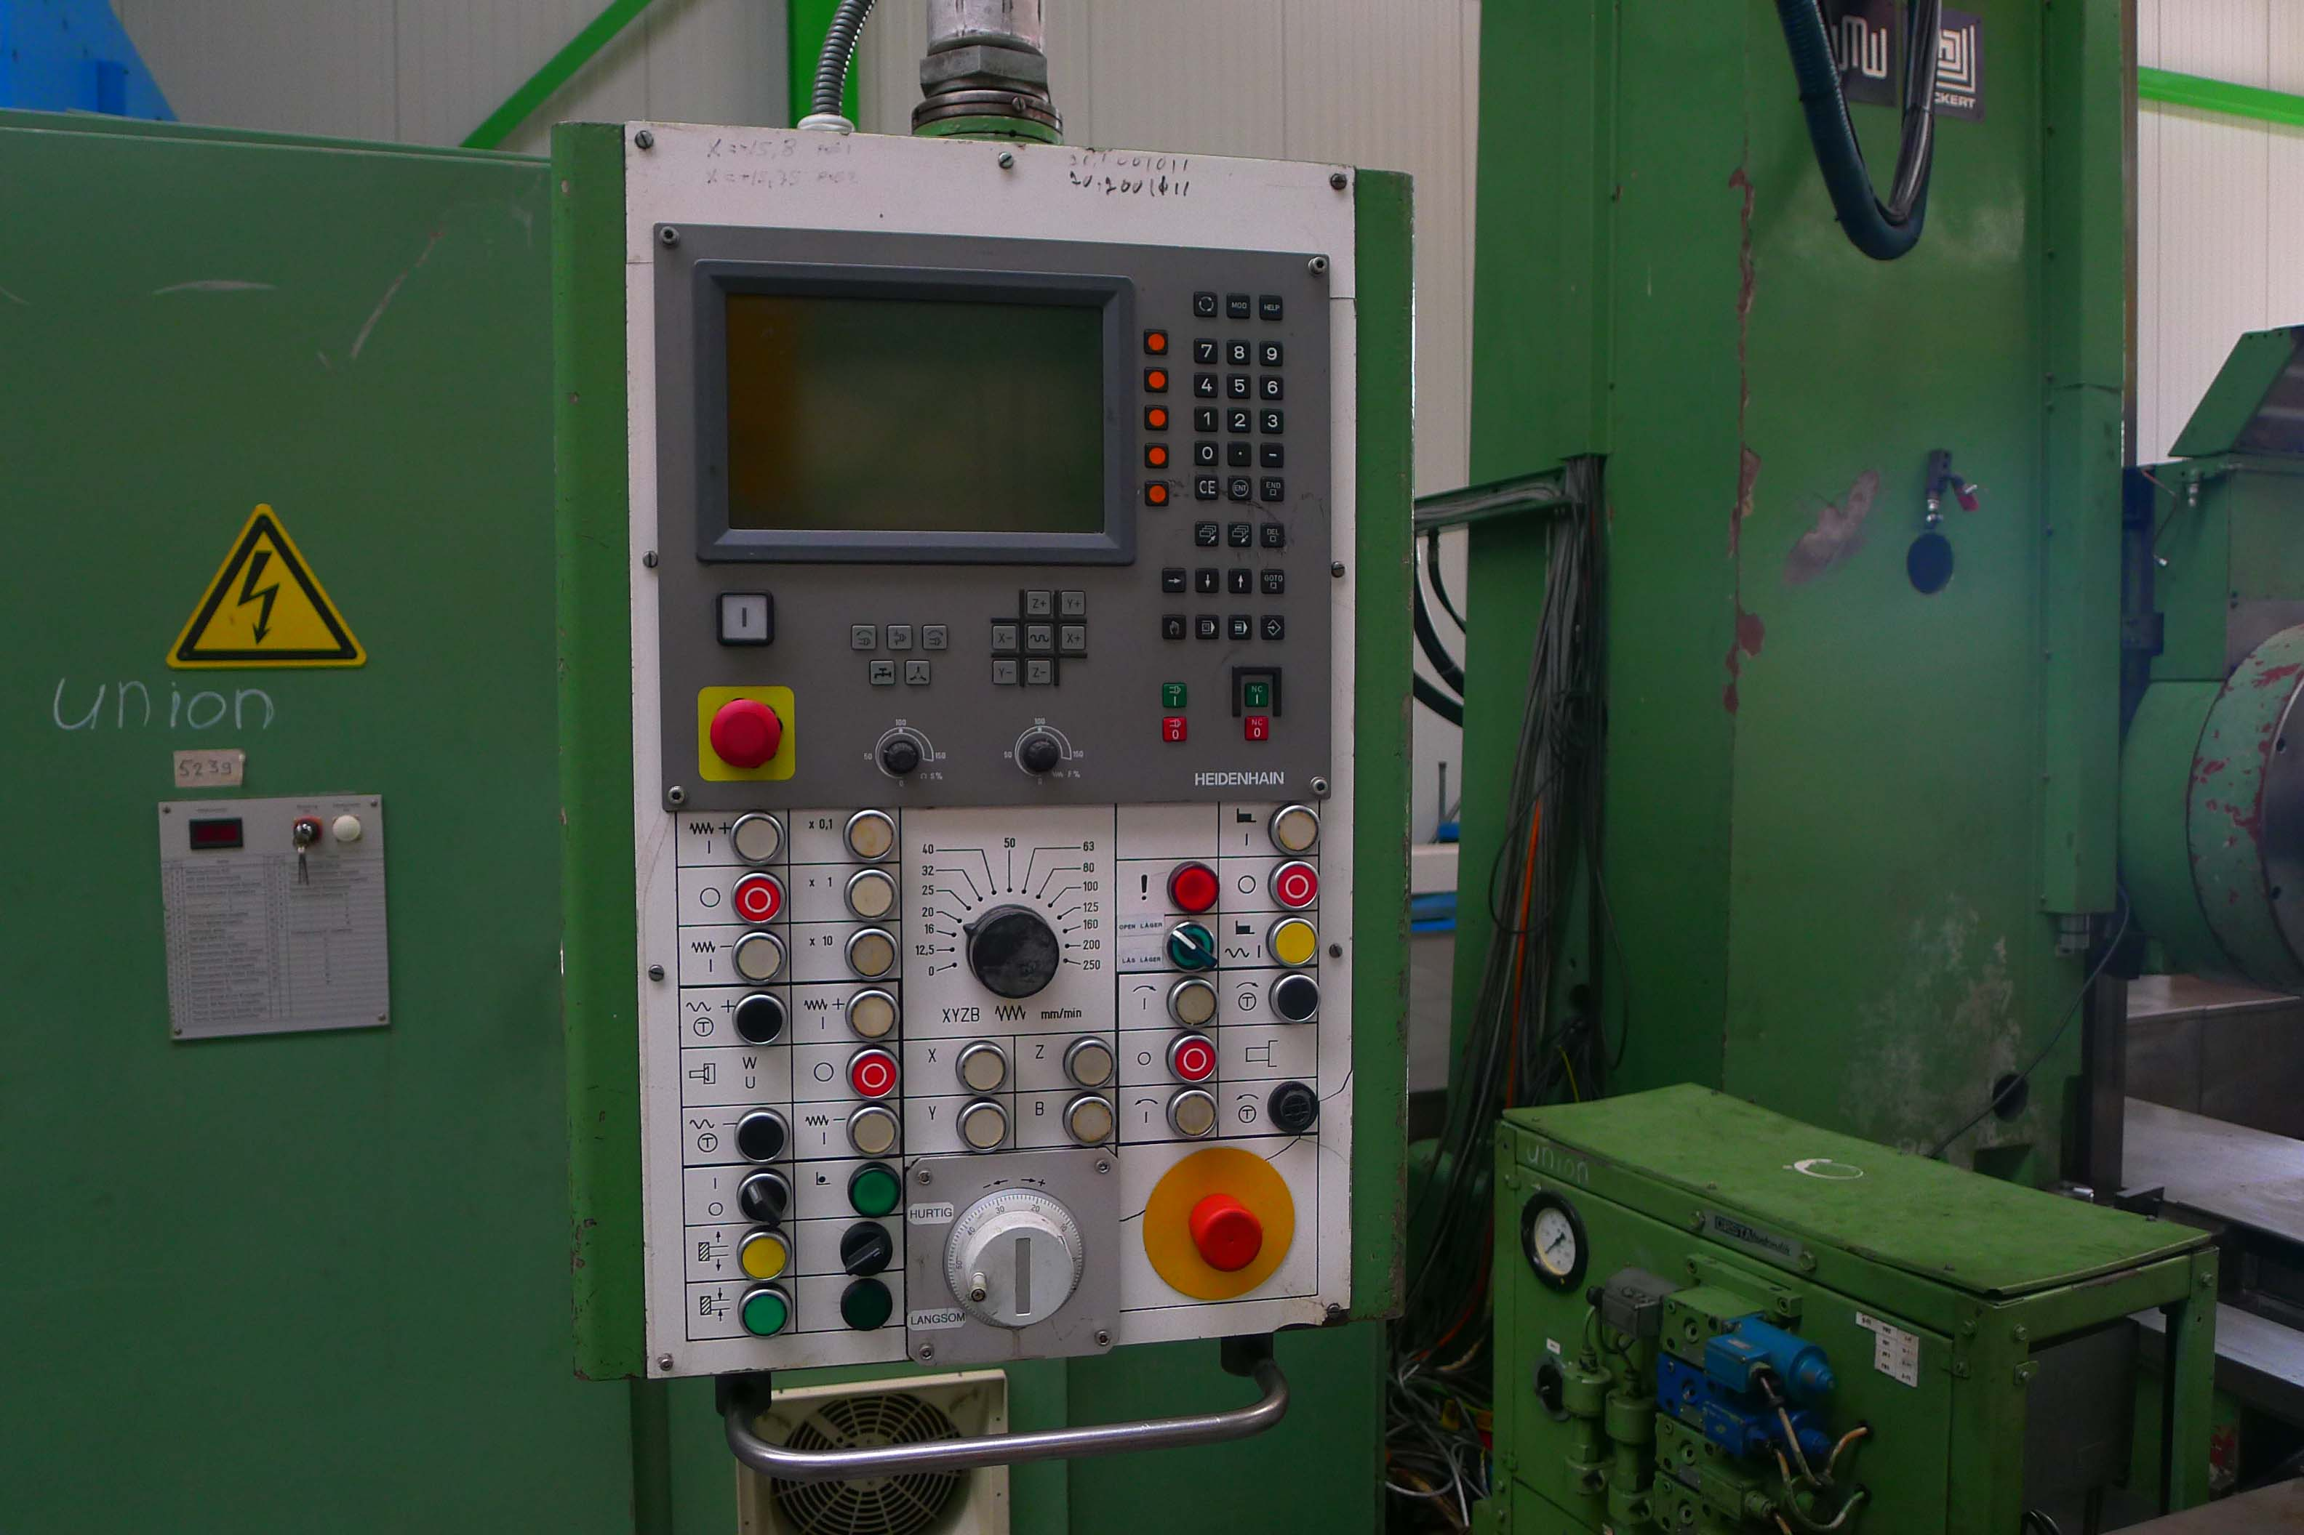
- Rotary table width : 1.400
- Table load : 6,3 to
- Table rotation : 360˚

- Spil diam boring. Ø : 110 / iso 50 / 33 kW
- Speeds : Vario 1.120 Rpm

- Feeds 5 – 2.500 mm/min
- Rapid feed 6.300 mm/min

- Dr. Heidenhain TNC 310 in 3 axis
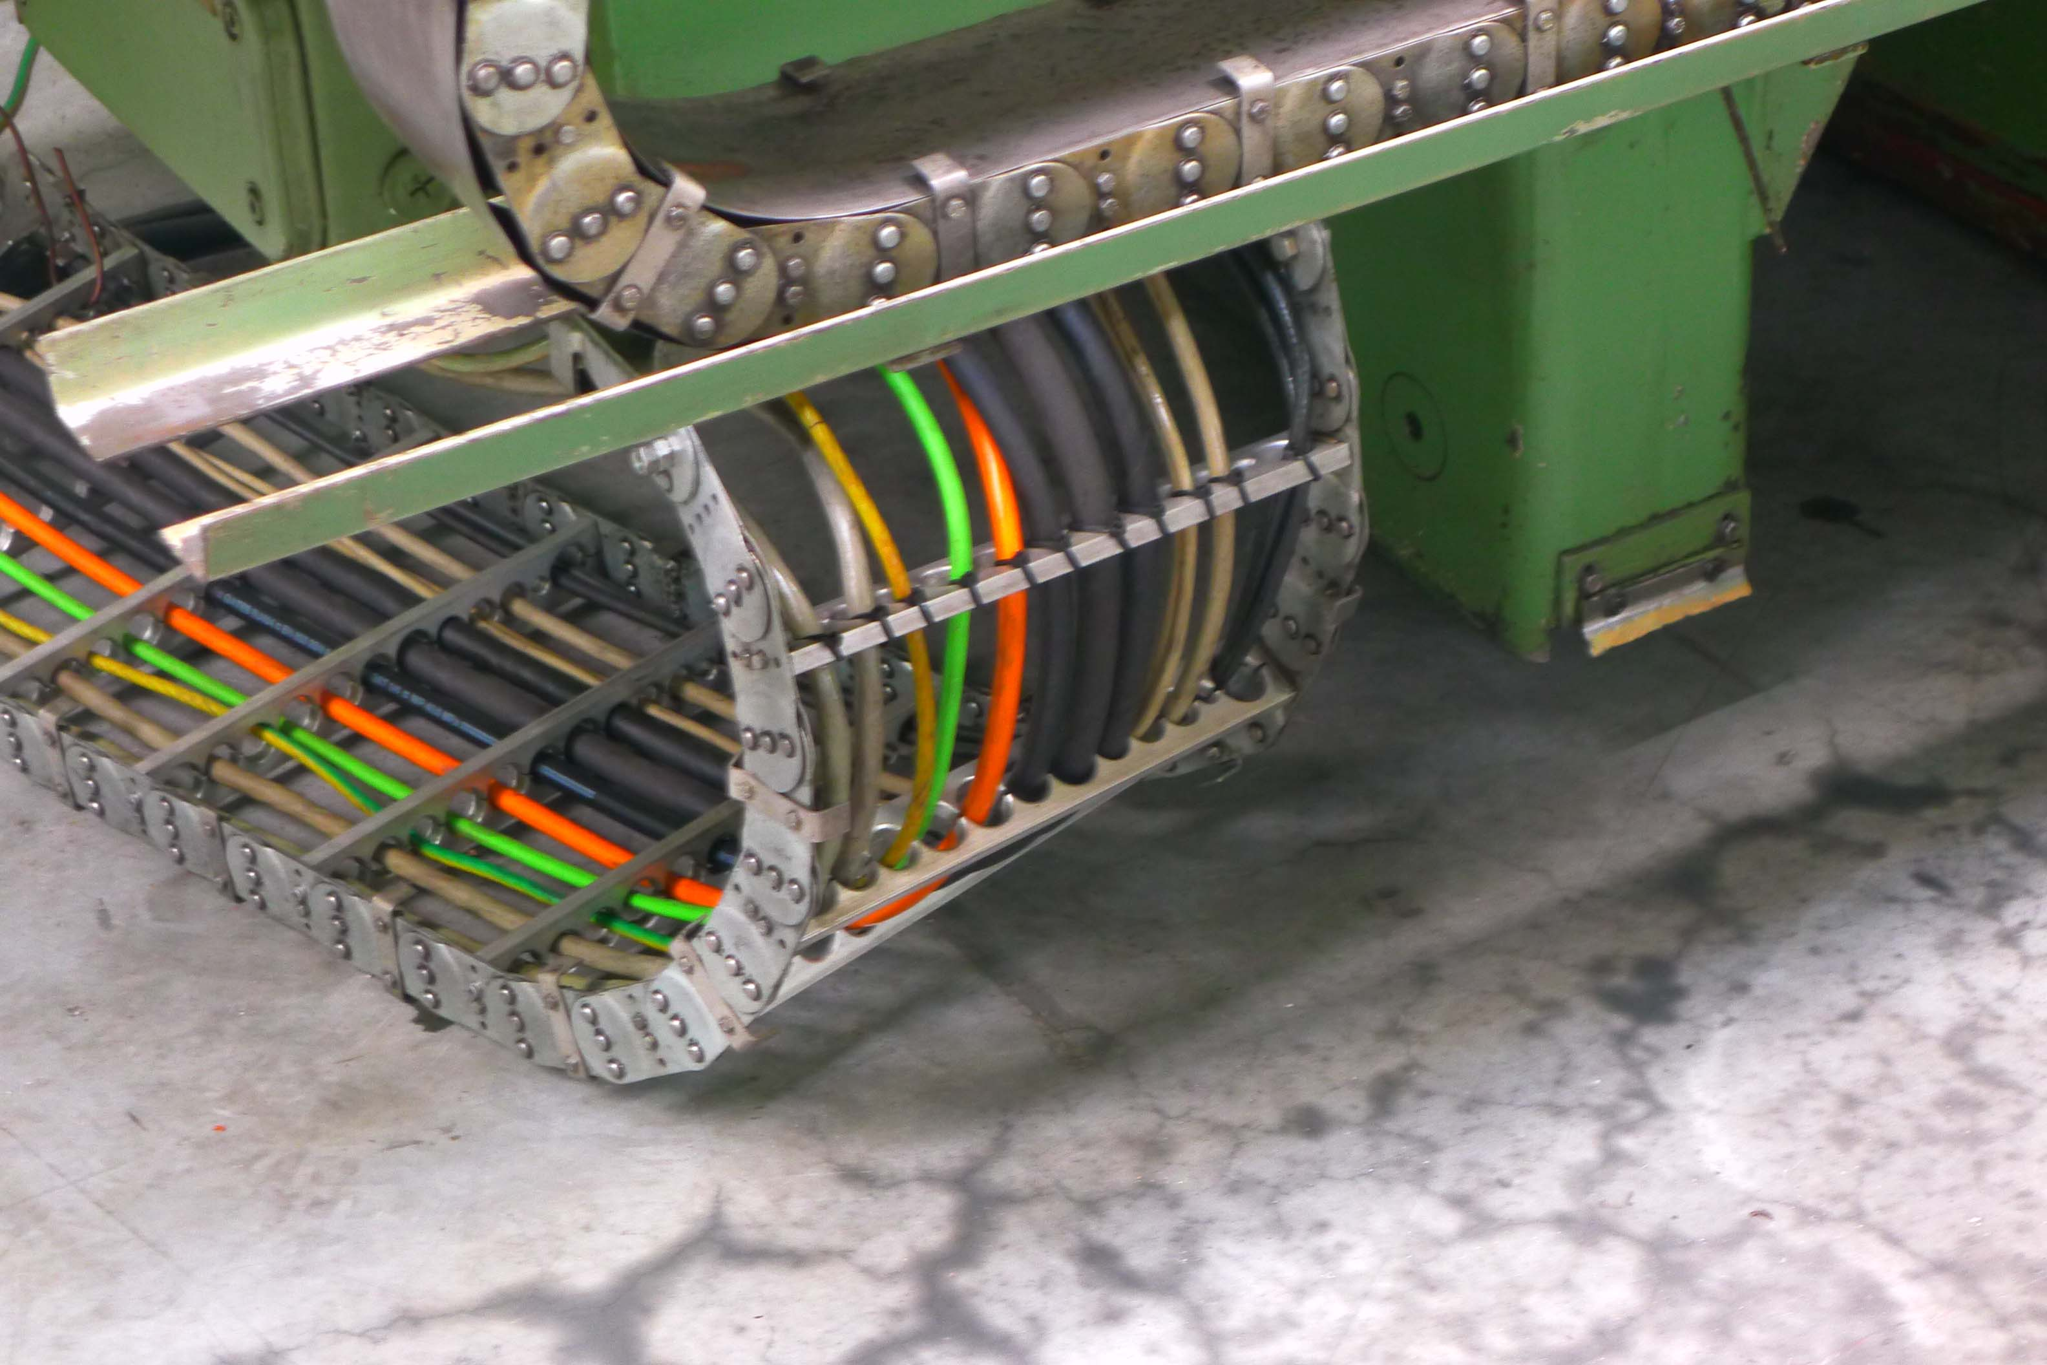
- Face plate Ø 700

- Dimensions
- Length : 6.700
- Width : 5.900
- Height : 4.700
- Weight : 25 ton

- Incl. Documentation / Drawings

Please Note: The above information has been obtained to the best of our ability and belief from, and from the manufacturers where possible. It is given in good faith, but its accuracy can not be guaranteed. Accordingly, it will not form a representation or constitute contractual terms. We advise you to check any vital details!

